

**MINDANAO**

**STATE**

**UNIVERSITY**

**–**

**MAGUINDANO**

**C**

**OLLEGE OF**

**A**

**RTS AND SCIENCES**

**Dalican, Datu Odin Sinsuat, Maguindanao 9601**

**DEPARTMENT OF ISLAMIC STUDIES**



**A Narrative Report in**

**On-The-Job Training Undertaken at National Commission On Muslim Filipinos (NCMF) located at 2nd Floor F&A Building, Sinsuat Avenue, Cotabato City.**

**In Partial Fulfillment**

**Of the Requirements for the Degree of**

**Bachelor of Arts in Islamic Studies**

**Major in Shari' ah**

**Submitted by:**

**NORMINA M. KAMSA**

**Trainee**

**Submitted to:**

**PROF. OMAR S. BUTUAN, MAIS**

**OJT Coordinator**



**MINDANAO**

**STATE**

**UNIVERSITY**

**–**

**MAGUINDANO**

**C**

**OLLEGE OF ARTS AND S**

**CIENCES**

**Dalican, Datu Odin Sinsuat, Maguindanao 9601**

**DEPARTMENT OF ISLAMIC STUDIES**



**A P P R O V A L S H E E T**

This On-The-Job Training Narrative Report undertaken at

**National Commission On Muslim Filipinos (NCMF) located at 2nd Floor F&A Building, Sinsuat Avenue, Cotabato City.**

is prepared and submitted by **NORMINA M. KAMSA** in partial fulfillment of the requirement for the degree of Bachelor of Arts in Islamic Studies is hereby endorsed for approval.

**PROF. OMAR S. BUTUAN**

OJT Coordinator/Trainee Supervisor



**MINDANAO**

**STATE**

**UNIVERSITY**

**–**

**MAGUINDANO**

**C**

**OLLEGE OF ARTS AND S**

**CIENCES**

**Dalican, Datu Odin Sinsuat, Maguindanao 9601**

**DEPARTMENT OF ISLAMIC STUDIES**



**A C K N O W L E D G E M E N T**

I would like to express my heartfelt gratitude to everyone who played a significant role in the successful compilation of my On-The-Job Training.

To my very supportive family, specially my parents **DINGCO K. MUSTAPHA, AHMAD K. ANSA** and to my brother **RAUF M. KAMSA**, and also to my Tito's and Tita's for their unwavering support, love,and guidance throughout my journey. Your selfless sacrifices and boundless encouragement have shaped me into the person I am today. Thank you for being my constant source of strength and inspiration.

To all my professors in Islamic Studies Department especially to our chairperson, Professor **RASUL A. GULO**. Thank you for your efforts, time, and patience just to make this internship happened. And also to our practicum adviser, Professor **OMAR S. BUTUAN** He was the one who motivated us to pass all the requirements needed. I would like to express my sincere gratitude for the undying and unconditional support, motivation and guidance.

To my co-trainee's, **THAHIRA A. ZACARIA, AKRIMA R. MIDTIMBANG, SHEENA P. UY, HAWLA K. LAKMAN, NORHATA MUSA, PAHIMA GUIABAL, AIDA DALGAN, LAILA GUIAMADIL, APIA M. ABDUL** thank you for your cooperation and support, I enjoy being with you for One month&1week and I hope that you would keep all the memories that we had together.

To the NCMF who provided me a good training that I can apply in the future. The NCMF employees treated us not as a student but one of them also.

Special thanks to sir, **Atty. Gapor G. Quituar**, ma'am **Carimah U. Hadji Ismael**, ma'am **HR**, ma'am **Beck**, ma'am **Baby**, sir, **Daudie**, ma'am **Rubby**, ma'am **Janima**, sir, **Ace**, sir, **Alipikre** and ma'am **Joh** for their generous support, coaching and companionship during my On-The-Job training.

They shared their expertise with me very generously and I have learned a lot from them on how to perform the standard ways, how to be responsible On-the-job Student trainee. Thank you for all the things that you've taught to us and for all the happy memories we had with you. Thank you once again for your great support in the successful completion of my On-The-Job training and for being part of your companionship.

Most importantly, to our Almighty Allah for whom everything provides the source of strength, knowledge and wisdom in completing my internship.

**TABLE OF CONTENTS**



**MINDANAO**

**STATE**

**UNIVERSITY**

**–**

**MAGUINDANO**

**C**

**OLLEGE OF ARTS AND S**

**CIENCES**

**Dalican, Datu Odin Sinsuat, Maguindanao 9601**

**DEPARTMENT OF ISLAMIC STUDIES**



Title Page…………………………………………………………………………………..............I

Approval Sheet ………..…………………………………......................................................2 Acknowledgement…………….………………………………………………............... .......4

Table of Contents……………………………………………………......................................6

Introduction …………………………………………………………….…......…….......……8

**CHAPTER 1 | OBJECTIVE OF THE PRACTICUM ......................................................9**

General Objective....................................................................................................................10

**CHAPTER 2 | COMPANY PROFILE................................................................................11**

Brief History of the Company................................................................................................ 13

Background of the Company.................................................................................................. 16 Company seal………………………………………………..………….…….................….. 17 Vision………………………………………………………………...................................... 18

Organizational Chart.............................................................................................................. 18

**CHAPTER 3 | WEEKLY ACCOMPLISHMENT REPORT ......................................... 19**

Weekly Accomplishment Report............................................................................................ 20

**CHAPTER 4 | TRAINEE ASSESSMENT OF THE PRACTICUM PROGRA…….....44**

Training Assessment...............................................................................................................45 Trainee Assessment of the OJT Program...............................................................................48  **CHAPTER 5 | OJT RELATED DOCUMENTS...............................................................49**  Final Evaluation Sheet...........................................................................................................55 Daily Time Record.................................................................................................................57Certificate of OJT Completion.........................................................................................58 OJT Blog...........................................................................................................................66

Resume .............................................................................................................................67

**I N T R O D U C T I O N**



**MINDANAO**

**STATE**

**UNIVERSITY**

**–**

**MAGUINDANO**

**C**

**OLLEGE OF ARTS AND S**

**CIENCES**

**Dalican, Datu Odin Sinsuat, Maguindanao 9601**

**DEPARTMENT OF ISLAMIC STUDIES**



The On-The-Job Training program is a supervised practiced of skills application to the Job functions of the different fields of specialization in a particular course offering. This provides the students the exposure and training experiences applicable and given a chance to apply the theories that they have learned from school and helps students to acquire relevant knowledge and skills by performing in actual work setting. Colleges and Universities required their students to undergo such training within a specific numbers of hour as a part of the curriculum.

The Bachelor of Arts in Islamic Studies is requiring Three Hundred (240) hours of On The-Job training exposure of the students in their field of specialization. Academic requirements completed if the students will undergo an On-the-job training. On-The-Job training provides students an opportunity in the actual field of work to the preparation for their future career.

On the other hand, an effective On-the-Job training also benefits the companies who accepted trainee's, first On-The-Job trainee's provides additional manpower for a lesser labor cost than a regular employee. Most of them are all eager to learn the ropes so chance are high that they will cooperate.

On-The-Job training can bring fresh ideas into the organization. Given the opportunity to speak their minds freely and without fear, they may be able to contribute significantly in brain storming sessions or research and eventually help improve the organization productivity. While training the intern, employees are in fact also teaching their employees to process of guiding the trainee's stretches their patience, develop skills and makes them more sensitive to the need and mind set of the younger generation.

Accommodating On-The-Job trainees can truly be beneficial not only to the trainee's but also to the companies that prove opportunity for this type of learning. Such training can be an investment that will be valuable to the company later on. This is also why trainees should take their training seriously as it become tool and possibly even a source of recommendation when they take a big lift from being student to career professional.

**CHAPTER 1**

**OBJECTIVE OF THE I.S. ON-THE-JOB TRAINING**

**GENERAL OBJECTIVES**

The purpose of the On-The-Job training is to provide the trainee with aptitude, competence, awareness in the real work place, and to develop skills relevant to trainee’s profession. The said program had given the trainee sufficient time to be familiar within the regular wok setting and so as to train themselves as normal employees.



**MINDANAO**

**STATE**

**UNIVERSITY**

**–**

**MAGUINDANO**

**C**

**OLLEGE OF ARTS AND S**

**CIENCES**

**Dalican, Datu Odin Sinsuat, Maguindanao 9601**

**DEPARTMENT OF**

**ISLAMIC STUDIES**



To learn through experience how to interact and communicate with people. Knowing how to handle and face different issues and still be diplomatic in both action and words as important.

To provide the essential as that need to perform their Job in the future such as being an independent, being responsible to do the task that the supervisors give to the trainee, to be able to learned and gain new things and new knowledge, to be able to mingle and know more about their supervisors, and to be able to improve their skills.

**CHAPTER 2**

**COMPANY PROFILE**

BRIEF HISTORY OF THE COMPANY

BACKGROUND OF THE COMPANY

COMPANY SEAL

VISION

ORGANIZATIONAL CHART

**BRIEF HISTORY OF THE COMPANY**



**MINDANAO**

**STATE**

**UNIVERSITY**

**–**

**MAGUINDANO**

**C**

**OLLEGE OF ARTS AND S**

**CIENCES**

**Dalican, Datu Odin Sinsuat, Maguindanao 9601**

**DEPARTMENT OF ISLAMIC STUDIES**



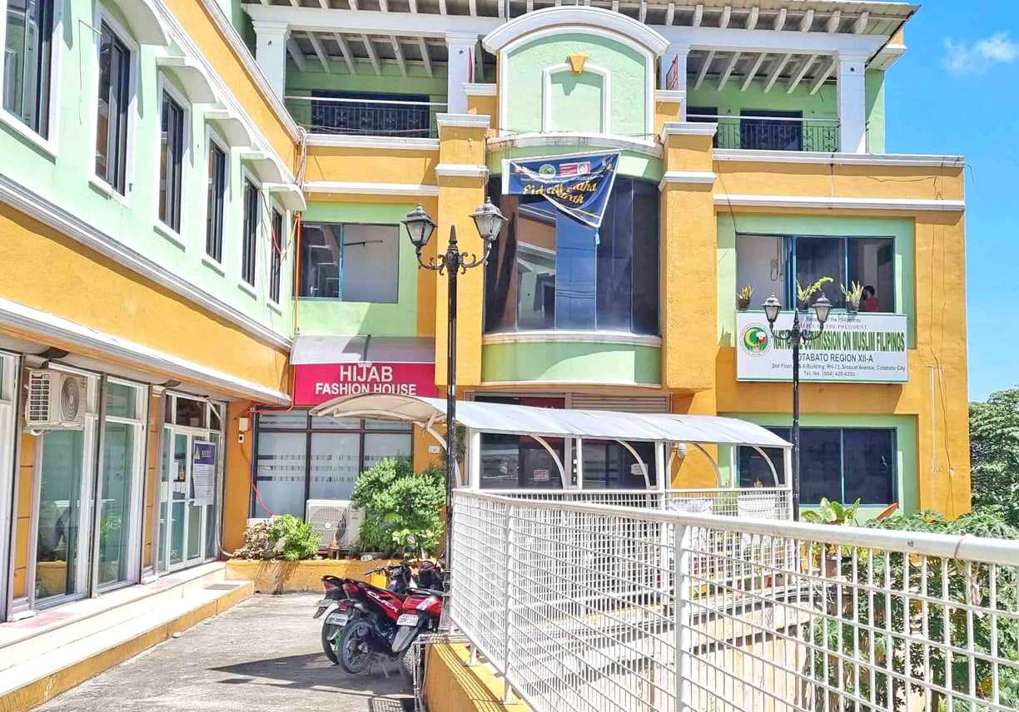

**NATIONAL COMMISSION ON MUSLIM FILIPINOS (NCMF) SOCCSKSARGEN REGION**

On July 23- 1979, President Ferdinand Marcos signed Executive Order No. 549 creating the Office of the Commissioner for Islamic Affairs. Rear Admiral Romulo Espaldon was appointed as commissioner.

On May 28, 1981, the Office of the Commissioner for Islamic Affairs was abolished and replaced with the Ministry of Muslim Affairs by Virtue of Executive Order No. 697 with Espaldon as Minister. Under his leadership, the Philippine Sharia’ah institute was launched and spearheaded the translation of the Code of Muslim Personal Laws from English to Arabic, and the first Madrasa policy conference was held to discuss the integration of Madrsa- type education into the Philippine Educational System.

Two months later, the Ministry was renamed Office of Muslim Affairs in order to minimize the number of ministries (25 at the time) and simplify the management of government. Other ministries that were reclassified as offices of were the Ministry of Budget and Ministry of Public Information.

On June 30, 1984, the Office of Muslim Affairs was merged with the Office of the Presidential Assistant on National Minorities to form the Office of Muslim Affairs and Cultural Communities (OMACC). It was headed by Simeon Datumanong.

On January 30, 1987, President Corazon Aquino divided the OMACC into three distinct and separate offices; the Office for the Muslim (OMA), the Office for Northern Cultural Communities (ONCC), and the Office for Southern Cultural Communities (OSCC). The OMA was headed by Candu Muharrif

On February 18, 2010, Congress enacted Republic Act No. 9997 which abolished the OMA and created the National Commission on Muslim Filipinos.

**BACKGROUND OF THE COMPANY**

With the signing of Republic Act 9997 (otherwise known as the Act Creating the National Commission on Muslim Filipinos) last February 18, 2010, the government has indeed re-affirmed its belief on the importance of the active participation of the Muslim Filipinos in nation building with due regard for their beliefs, customs, traditions, institutions and aspirations.

In brief, the Commission shall serve the following functions:

Advise the President in the formulation, coordination, implementation, and monitoring of policies, plans, programs and projects affecting Muslim Filipino communities;

Act as the primary government agency through which Muslim Filipinos could seek government assistance and redress, and serve as medium through which such assistance may be extended to Muslim Filipinos;

Monitor and evaluate the performance of all existing policies and development programs of the government that seek to strengthen and uplift the socio-economic conditions of Muslim Filipinos and identify areas that need government intervention and support;

Provide legal and technical services for the survey, adjudication, titling, and development of Muslim Filipino ancestral lands and settlements proclaimed by the government for the Muslim Filipinos and issue certificates of ancestral land/domain titles; and

Undertake studies, establishment and maintenance of ethnographic research centers and museums on the culture and institutions of Muslim Filipinos. This is for purposes of policy formulation and program implementation as well as for the purpose of preserving their historical heritage.

The NCMF has nine commissioners including the Secretary/Chief Executive Officer, who will represent the Commission at cabinet-level meetings with the President. The Commission will cover both local and national concerns of Muslim Filipinos, including the implementation of economic, educational, cultural, and infrastructure programs for Muslim Filipino communities.

Among the main programs of the NCMF is the coordination of the annual hajj pilgrimage to Makkah, participation in international Qur’an reading competitions, and other educational and cultural activities of relevance to Muslim Filipino communities. Muslim Filipino students who intend to study abroad should coordinate with the NCMF to have their academic documents properly authenticated before traveling to the country where they will pursue their higher education.

Senator Juan Miguel Zubiri, its principal sponsor, said that the creation of the Commission is in consonance to national unity and development. Cong. Dimaporo on the other hand, emphasized the significant role of the Commission to ensure the delivery of allocated resources for education, economic and cultural development programs for the Muslims.

**POWERS & FUNCTIONS**

(a) Provide advice and assistance to the President in the formulation, coordination, implementation, and monitoring of policies, plans, programs, and projects affecting Muslim Filipino communities; when so authorized, represent the President on matters concerning Muslim Filipino communities; serve as a link between the President and public or private agencies, internal or external, that are involved in such programs and projects; and recommend such affirmative actions as may be necessary for their efficient and effective implementation;

(b) Undertake and coordinate development programs and projects for the advancement of Muslim Filipino communities, including designing, implementing and maintaining settlements for Muslim Filipino communities, Provided That the Commission shall not take jurisdiction or ownership over lands and bodies of water traditionally and occupied by Indigenous peoples and within the identified ancestral domains of the National Commission on Indigenous Peoples: Provided, further, That lands may be identified by the Commission for the purpose of settling the homeless and displaced Muslim families to improve the conditions of the members of the Muslim communities;

(c) Act as the primary government agency through which Muslim Filipinos can seek government assistance and redress; serve as the medium through which such assistance may be extended to Muslim Filipinos; for this purpose, the Commission is hereby authorized, subject to existing auditing rules and regulations, to give grants-in-aid out of its appropriations or other appropriate funds to cooperating government agencies for such programs or projects for the development of Muslim Filipino communities; provide services including legal assistance, medical aid, relief, rehabilitation and other forms of assistance for socio-economic upliftment of Muslim Filipino communities;

(d) Participate in the peace process involving conflicts between Filipino Muslim groups and/or individuals and the government in cooperation with appropriate agencies, individuals and institutions. Pursuant hereto, the Commission’s Secretary or his/her duly designated representative shall sit aa a regular member of the government’s peace panel negotiating peace with the Muslim Filipino groups or individuals;

(e) Enter, subject to existing laws, policies, and guidelines, into contracts, agreements or arrangements with government or private agencies/entities as may be necessary to attain the objectives of the Commission;

(f) In accordance with existing laws, rules and regulations and subject to guidelines provided by the Office of the President, promote and enhance the development of domestic trade and commerce among the members of the Muslim Filipino communities; promote or facilitate the establishment by members of the Muslim Filipino communities joint venture and investments in cooperation or coordination with existing public enterprises, corporations or private entities; initiate and/ or organize, in accordance with pertinent laws, rules and regulations, enterprises based on the principles of Islamic business and finance for the benefit and welfare of the Muslim Filipino communities;

(g) Recommend to the Department of Budget and Management (DBM) the proposed expenditure for the development of all Muslim Filipino communities;

(h) Promote and develop the Philippine Halal Industry and accredit halal-certifying entities/bodies for the utmost benefit of Muslim Filipinos and in partnership or cooperation with appropriate agencies, individuals and institutions here and abroad;

(i) Develop criteria for allocating additional resources for education, economic and cultural development programs;

(j) Monitor and evaluate the performance of all existing policies and development programs of the government that seek to strengthen and uplift the socioeconomic conditions of Muslim Filipinos and identify areas that need government intervention and support;

(k) Acquire, lease or own property or assets in whatever form as may be necessary, and sell or otherwise dispose of the same, and serve as the custodian or administrator of such lands or areas and other properties or assets the President may reserve for the benefit of Muslim Filipino communities;

(l) Solicit and accept grants, donations and gifts, in cash or in kind, in whatever source, in coordination with the appropriate agency for the benefit of the Muslim Filipinos, and administer the same in accordance with the terms thereof, or in the absence of any condition, in such manner consistent with the interest of Muslim Filipinos as well as existing laws;

(m) Undertake studies, establish and maintain ethnographic research centers and museums on the cultures and institutions of Muslim Filipinos for policy formulation and program implementation and for the purpose of preserving their historical heritage;

(n) Certify, whenever appropriate, membership of persons in Muslim Filipino communities for purposes of establishing qualifications for specific requirements of government and private agencies or for benefits as may be provided by law;

(o) Provide legal and technical services for the survey, adjudication, titling, and development of Muslim Filipino ancestral lands and settlements proclaimed by the government for the Muslim Filipinos;

(p) Assist the National Statistics Office (NSO) in conducting census on the actual population of Muslim Filipinos in the country;

(q) Administer all programs, projects and activities, formulate the necessary rules and regulations, and coordinate with pertinent offices to ensure the success of the annual Hajj (pilgrimage) to Mecca, Kingdom of Saudi Arabia;

(r) Promote the development of a Hajj Assistance Fund that shall be created from contributions of Muslim Filipinos and other donors which shall be used to support the financial needs of deserving Muslim Filipinos intending to participate in the annual Hajj;

(s) Administer and hold in trust awqaf (endowment) properties and/or awqaf institutions, and receive by way of grant, donations or gifts, awqaf investments in accordance with the principles of Islamic investments and finance;

(t) Prescribe rules and regulations for the establishment of awqaf institutions, administration of awqafassets, and settlement of disputes among awqaf beneficiaries pursuant to the general principles of Shari’ah(Islamic Law);

(u) Formulate and adopt continuing programs and activities to strengthen Madaris (plural of Madrasah) schools, Islamic Studies, and Shari’ah and Islamic jurisprudence, in coordination with appropriate agencies of the government;

(v) Promote and supervise, in coordination with appropriate agencies of the government, the implementation of the Madrasah education system throughout the country except in the Autonomous Region in Muslim Mindanao (ARMM) where the system shaU be implemented and supervised by the Department of Education-ARMM; and provide assistance in the expeditious accreditation of Madrasaheducational institutions with the appropriate agencies of the government:

(w) Ensure that the curriculum of the Madrasah education system shall conform with the basic curriculum of the national formal education system which, along with teachings on Arabic Language, Islamic Studies, and Filipino and Islamic Values shall include, among others, the subjects on Filipino and English Grammar and Usage, Philippine History and Geography, Science and Technology. Mathematics, Physical Education and Sports Development, and Vocational Education to secure the local and international competitiveness of Muslim Filipino graduates from the Madrasah educational institutions;

(x) Develop criteria for the grant of local and foreign scholarships and the selection of deserving students and teachers of Madrasah and other educational institutions;

(y) Provide and/or facilitate access to local and foreign scholarships to deserving Muslim Filipinos in coordination with formal educational institutions here and abroad;

(z) Ensure the continuous transfer of technology to Muslim Filipino communities to uplift the quality of life of Muslim Filipinos;

(aa) Promulgate such rules and regulations and exercise such powers and functions as may be necessary to carry out the purposes and objectives outlined in this Act; and

(bb) Perform such other functions as may be necessary for its effective operations and continued enhancement as a government entity.

**COMPANY SEAL**



.

**VISION**

The premier government agency committed to maintain the integrity, values, culture and well-being of Muslim Filipinos geared towards national unity and development.

**MISSION**

Dedicated to promote, preserve and develop self- reliant communities to become nation – builders and peace makers by:Formulating timely policies and programs;

Muslim Filipinos through multi-sectoral unified efforts guided by Islamic values and principles.

**CORE VALUES**

God- Centered Trabaho ko, Ibadah Ko. Excellence Finding solution creatively Teamwork Strength in Unity

**NCMF QUALITY POLICY**

We, at the National Commission on Muslim Filipinos, are committed to perform with the highest quality of service the mandate of the Commission in improving the well- being of Muslim Filipinos.

To achieve this, we shall:

Adhere to the country’s laws and other legal issuances and with due consideration to the cultural sensitivity of the stakeholders in the delivery of service.

Ensure timely and responsive delivery of services for the satisfaction of customers, clients, and partner organizations.

Strive to continually improve the effectiveness of the Quality Management System so that every Muslim Filipino and Relevant Interested Party shall be served fairly and justly.

Trabaho Ko, Ibadah Ko!

**ORAGANIZATIONAL CHART**

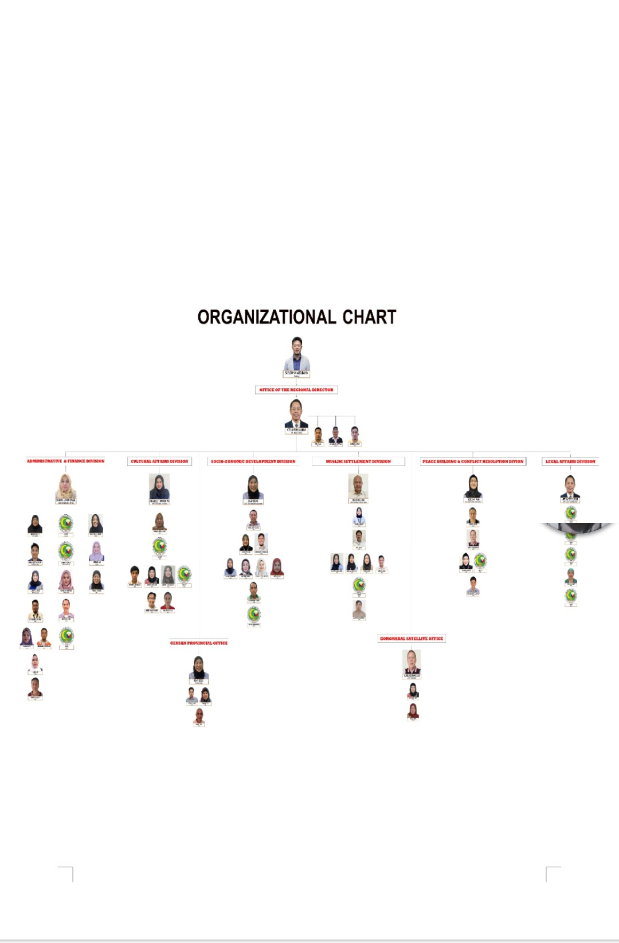

**CHAPTER 3**

**WEEKLY ACCOMPLISHMENT**

**REPORT**

WEEKLY ACCOMPLISHMENT REPORT

ACTUAL WORK PHOTOS

 **MINDANAO STATE UNIVERSITY – MAGUINDANAO**

**College of arts and sciences**

Dalican, Datu Odin Sinsuat, Maguindanao

**ACTUAL WORK PHOTOS**

**TRAINING ASSIGNMENT**

The whole period of the On-The-Job Training, I and my co-trainee's designated in National Commission on Muslim Filipinos (**NCMF**). Our mentor or trainee supervisor Ma'am Carimah U. Hadji Ismael,CPA assign us to write all the important information of every employee payment and payroll according to year and month . Our agency focuses only on the expenses and goodness of service for their company they also concern about the every employees and clients concerns about the company. The admin focus about the finance and legal transaction in NCMF.



**MINDANAO**

**STATE**

**UNIVERSITY**

**–**

**MAGUINDANO**

**C**

**OLLEGE OF ARTS AND S**

**CIENCES**

**Dalican, Datu Odin Sinsuat, Maguindanao 9601**

**DEPARTMENT OF ISLAMIC STUDIES**



As an Islamic Studies trainee, I always do and finished my work on and before the time ended, I and Hawla always making sure that the outcome of our work is great so that our agency appreciates us. I am thankful that Hawla K. Lakman is my partner during our OJT.

Alhamdullilah everything was in control, their environment is so friendly, nice and air conditioned. And a big benefit for everyone because of the free internet connection. The method of operation within our team is well organized and no pressure at all because everyone is responsible for their task. As time went by, I learned to value intimacy and good relationship.

**ASSESSMENT OF THE OJT PROGRAM**

**RELATED LEARNING EXPERIENCES**

On-The-Job Training is one of the best training methods because it is planned, organized and generally help the students to increase their productivity and skills. As a trainee, it helps me a lot to enhance my skills, improve my confidence and learn something new from every task given to me. After two (1) month of training, I learned many things. As a trainee who far in the family, I become a hard working person and learned to accept my failure and should learn from it and appreciate even the simplest things. I learned to value the time because in reality world time management is more important to manage by every individual person else nobody would hire you. Such a great opportunity for me as a trainee, it's never been easier when it comes to the first timer but I have to be strong for my future and Family. What I've learned a lot, my learning's will be my key to have a successful future. I am always motivated by this quote " All things are difficult before they are easy ".

On the first week of the training it should be adjustments and adopting period to the new environment, challenges and experience. It is also the week where our supervisor gives us task where the writing of every important details of employee.

Another week had then come, they taught us about how to process legal papers. They also taught us the importance of every transaction and legal papers like Affidavit of Marriage, loss, Brgy. Certificate, Notarization, Personal Data Sheet (PDS) and more.

The legal division also taught us the process and importance of legal papers , the Importance why every paper has book number, page number and document number.

**INTERPERSONAL EXPERIENCES**

The training I had in the National Commission on Muslim Filipinos is learning many experience each day, I was exposed in the field of being an Islamic Studies Student. Become familiar with documents prepared by the Legal Division by processing it. I become familiar with how to file a complaint as well as the answer. I become familiar to the any kind of Affidavits and Legal papers. Aside from those things, I learned how to encode affidavits. I also learned to be more sociable and to adjust myself in the environment where I am working and who I am working with.

Therefore, the whole duration of the On-The-Job Training was excellent and my communication skills, technical skill, socialization skill, writing and reading skill were developed. Nothing beats experience as a perfect learning tool. This On-The-Job training served as my stepping stone to pursue my dreams.

**MEMORABLE EVENTS**

Actually, the whole period of the training was memorable experience, but then the most memorable event during our On-The-Job Training is when we the division of peace building or the (PBCRD) conduct a series regarding Mediation and Conflict Resolution.

Ma’am beck really did her best and other employee to conduct this lecture or series, we really appreciate their kindness and being so comfortable to us. The series was so memorable and we learn a lot each session we really learn and appreciate every wisdom of their lecture and those advise and knowledge that they shared to us will never go unnoticed.

After (7) days of the lecture we celebrate it after, not just the learning and knowledge they give they also celebrate our successfully attainment of the lecture and gave us certificate. Alhamdulillah and Thank you so much to the division of (PBCRD), especially to Sir, Alipikre and Ma’am Beck.

**CHAPTER 5**

**ON-THE-JOT TRAINING**

**RELATED DOCUMENTS**

FINAL EVALUATION SHEET

DAILY TIME RECORD

CRETIFICATE OF OJT COMPLETION

OJT MEMORANDUM OF AGREEMENT

OJT BLOG

RESUME

**OJT BLOG**